# **Capstone Project - Car accident severity**

## 

## **Introduction**

Road safety is one of the main concerns for every government in the world. Approximately 1.35 million people die in road crashes each year, on average 3,700 people lose their lives every day on the roads, while 20-50 million people suffer non-fatal injuries (resulting in long-term disabilities). For United States, the road crash is also a security risk for drivers and pedestrian. More than 38,000 people die every year in crashes on U.S. roadways. The traffic fatality rate is 12.4 deaths per 100,000 inhabitants and the terrible traffic security condition also cause 4.4 million people suffering from serious injure. The economic and societal damages of this single problem cost every citizen 871 billion dollars. To ease the harsh traffic security issue and offer a solution for the relevant department in the U.S. government, a prediction for the severity of car accidents and a detailed data analysis is crucial for the policy maker.

With the relevant data, I could use data science techniques to explore the incident severity in Python. The core aim of this report is to locate the key factor that lead to an incident in Seattle, as well as to offer some basic descriptions about the Seattle traffic incidents. To achieve this target, this report will present the answers to several issues. I shall start with the location of the incident on the map and the hot areas for the incident; then I will turn to the exploratory analysis for the collision type, location type and severity (the incident scale); in the end, I would build up a model to analyze the factors which may affect the incident severity.

**Data Section**

1. Data Description

To explore the problems, I utilize some database to acquire data.

* The example dataset comes from the web page of Coursera Course *Applied Data Science Capstone.* The .csv file contains 19,4673 pieces of collision records of Seattle. The data for this capstone project is offered by SDOT Traffic Management Division and recorded by Traffic Records Group. It covers the annual collisions data from 2004 to present. The time frequency of this dataset is weekly and it shows the traffic collision records in Seattle.The example datasets contain 194,673 pieces of records starting from 2004. The attributes in the datasets covers the weahter condition, road condition, collision type and fatality.
* The other relevant data comes from the database of Seattle government. The main data source is from Seattle Department of Transportation. The basic background information is offered by this department.

1. Data Exploration

This sub-section presents the exploratory data analysis for the example dataset from Coursera Course *Applied Data Science Capstone.* After the primary data cleaning procedure, the remaining useful attributes covers the collision type, address type, severity description, collision scales and potential factors of the collision (weather, speed, road condition, light condition and so on). The following data description comes from all remained data attributes.

Since 2004, the number of collisions has remained on a high level. This figure keeps around 10,000. The following bar chart shows that there is only a fluctuation in last 16 years. In recent 5 years, the number of incidents has decreased. But the incident scale has no significant change in this time period.

*Figure 1 The numbers of traffic incidents (Annually) in Seattle in last 16 years*

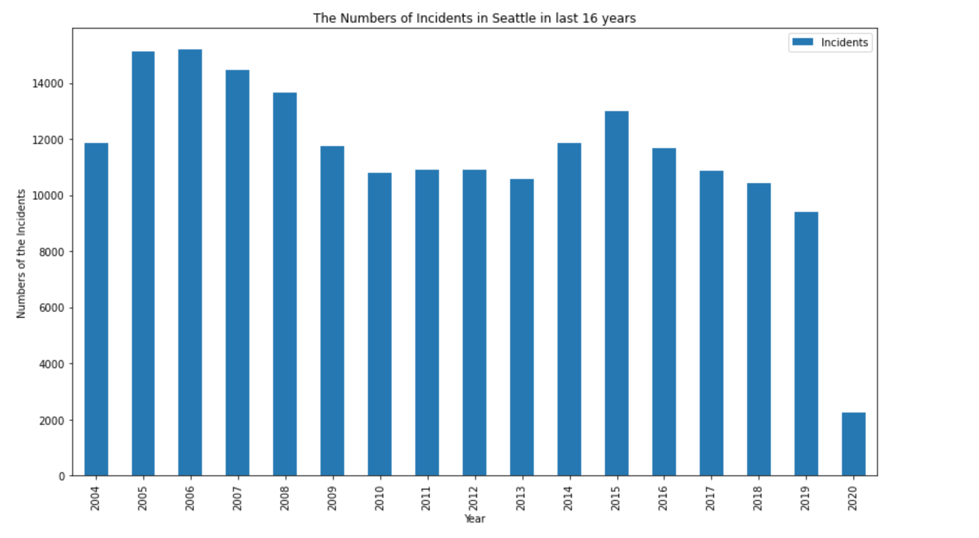

The incident scale is demonstrated by the numbers of involved pedestrians, bicycles and vehicles (the main objects on the road). The annual statistics of the incident scale is as follows.

*Figure 2 The scales of traffic incidents (Annually) in Seattle in last 16 years & The numbers of involved vehicles (Annually) in Seattle in last 16 years*

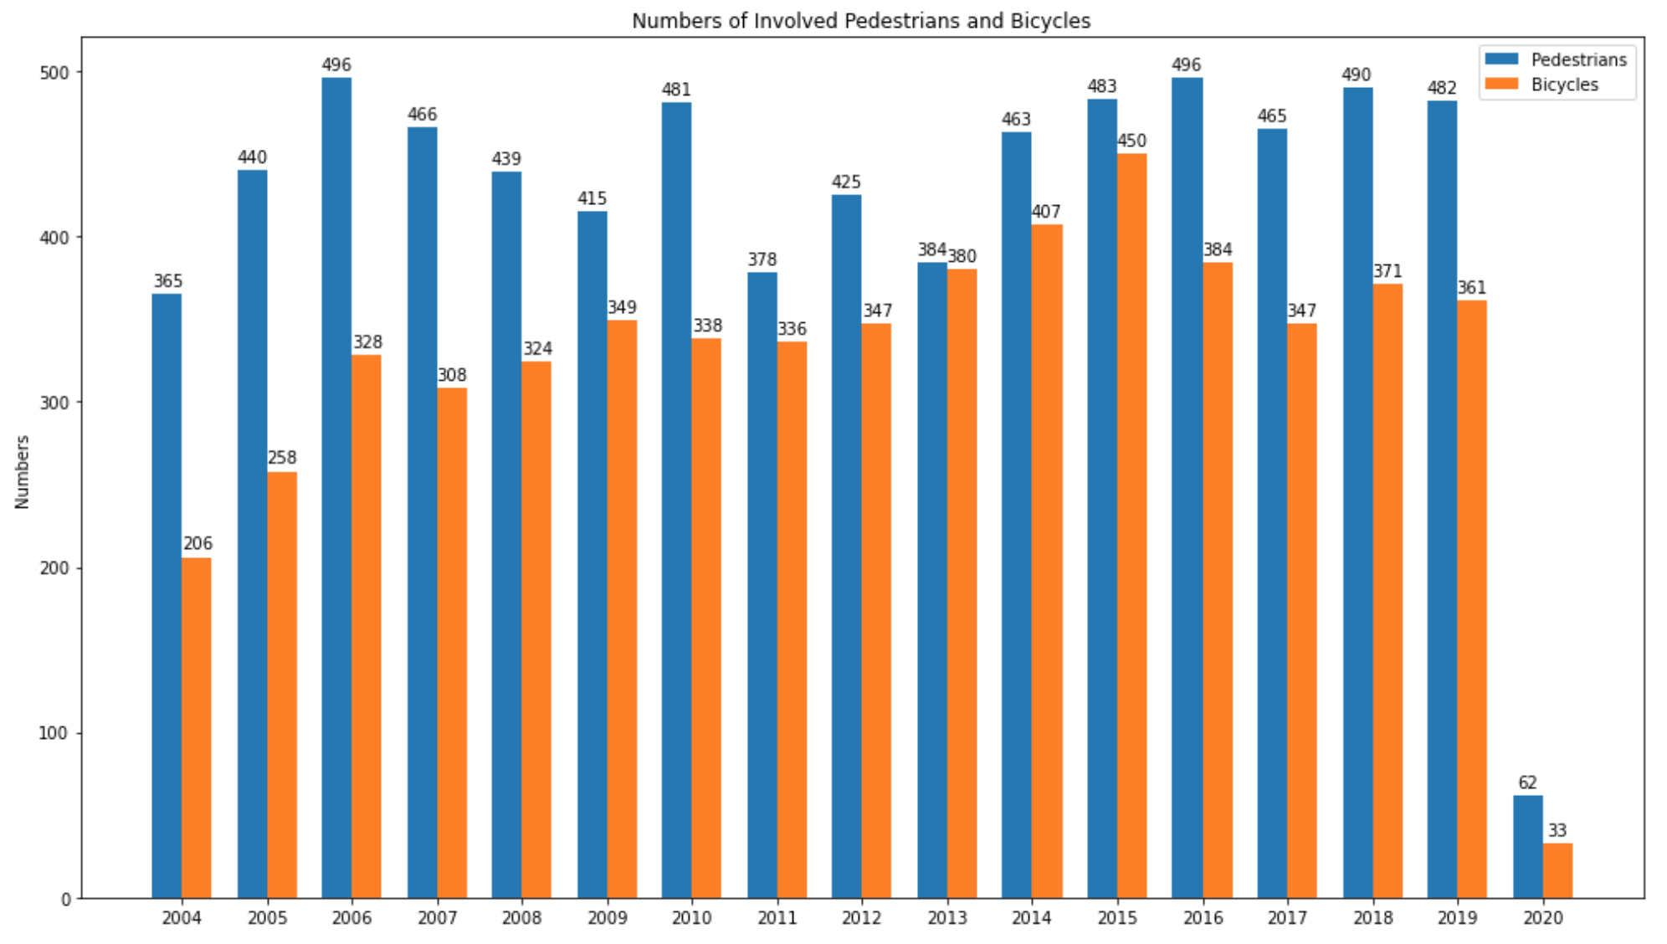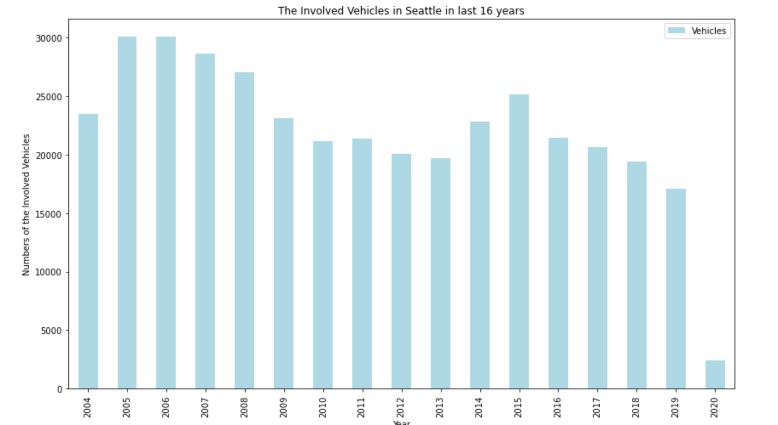

Figure 3 infers that the number of involved pedestrians has been on a high position while the number of involved bicycles has been gyrating up since 2004. However, the number of the involved vehicles has been in a decreasing trend with some small fluctuations.

In this report, I would analysis and predict the target variable SEVERITYCODE and also search for the relevant factors which affect the target variables. In the following table, I remove all the irrelevant data attribute away and list the rest necessary data columns.

*Table 1 The used variables in this report*

|  |  |
| --- | --- |
| Variables | Description |
| Longitude | The geographic data for incident locations |
| Latitude |
| OBJECTID | The series number of the incidents |
| **SEVERITYCODE** | **The code to describe the severity of each collision** |
| ADDRTYPE | Whether the collision happened in block or intersection |
| JUNCTIONTYPE | The decription of the collision places |
| ROADCOND | The road status when collisions happened |
| LIGHTCOND | The light condition when collisions happened |
| WEATHER | The weather condition when collisions happened |
| PERSONCOUNT | The number of people involved in the incidents |
| VEHCOUNT | The number of vehicles involved in the incidents |
| UNDERINFL | Whether the driver was under alcohol or drugs influence or not |
| INATTENTIONIND | Whether the collision was caused by inattention |

**Exploratory data analysis**

To analyze the main factors for the collision, this section provides the primary exploratory analysis for the dataset. It shows how the collision type, weather, junction type and other attributes affect the

*Figure 3 The severity distribution for different collision type*

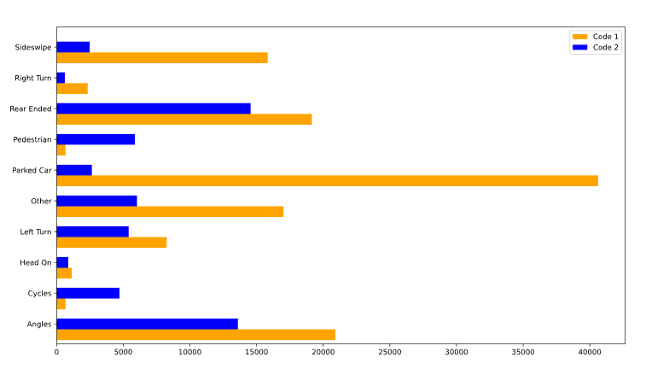

collision severity. Figure 3 is about the collision severity of different collision type, inferring that property damage only collision happens more frequently than injury collision among all collision types.

Figure 4 shows how the collision severity distributes at different areas of roads.

*Figure 4 The collision severity distribution in different areas of the roads*

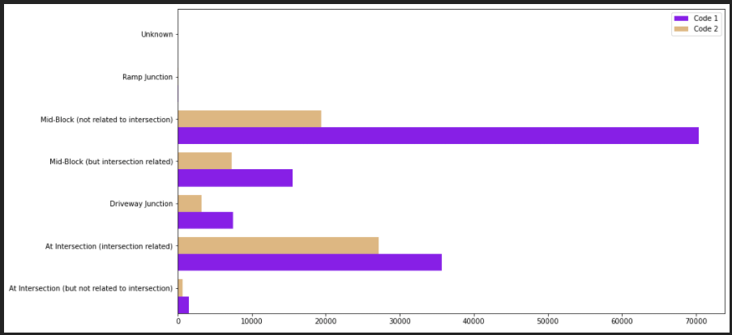

Figure 5, 6 and 7 separately provide a glimpse of the collision severity happened under different external circumstance. From the figures we could find that all the mentioned factors, including collision type, junction type and the external conditions (weather, road and light conditions) have different level influence on the collision severity. Then we could turn to machine learning algorithm section.

*Figure 6 The collision severity distribution under different weather conditions*

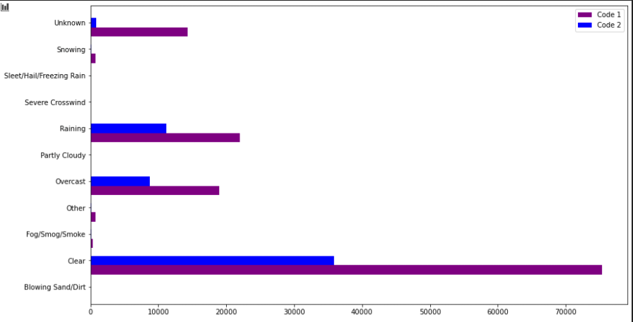

*Figure 7 The collision severity distribution under different light conditions*

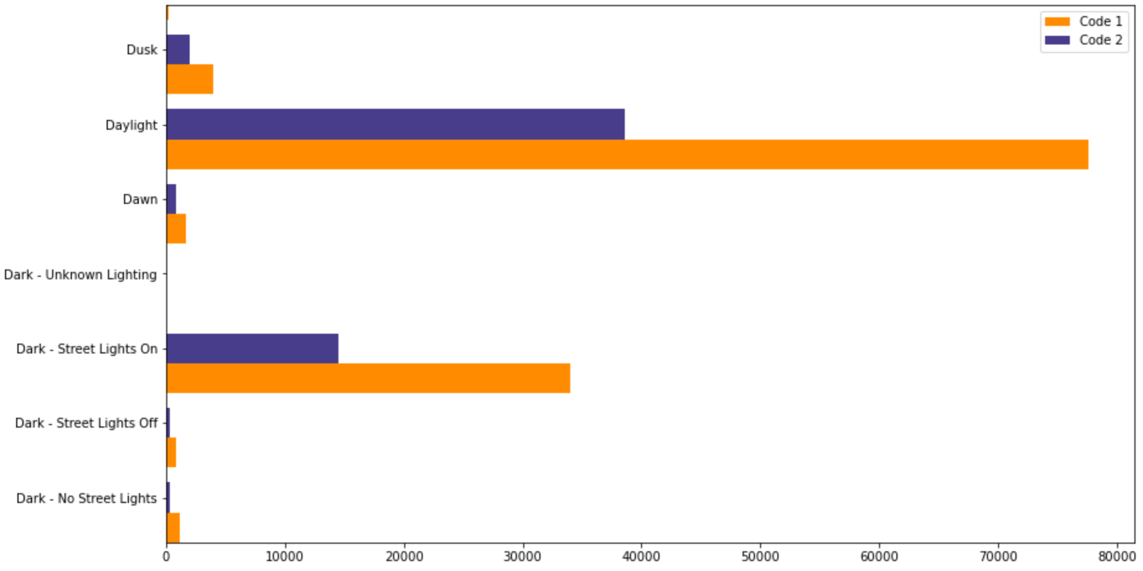

*Figure 8 The collision severity distribution under different light conditions*

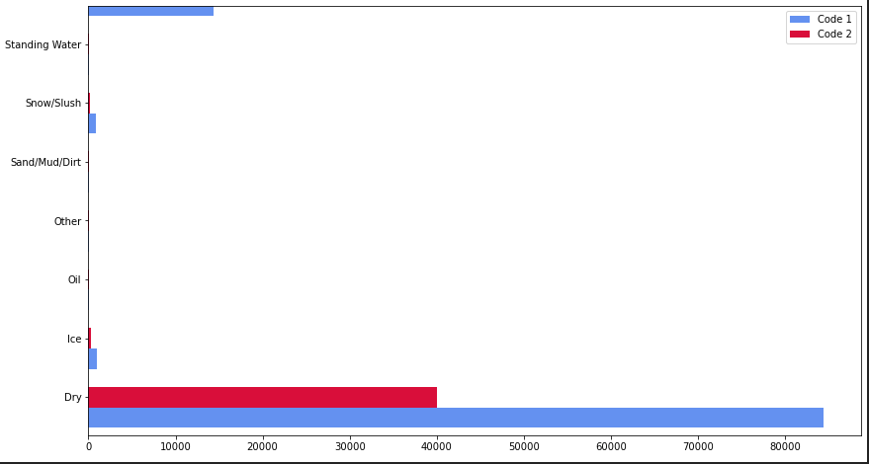

The upper exploratory analysis results demonstrate how the recorded factors in the dataset affect the collision severity separately. The following section would apply several popular machine learning algorithms and build up models to analysis and predict the collision severity.

**Methodology**

1. Data Pre-processing

With the help of python library *pandas*, I finished the data cleaning process through several procedure. This step makes the dataset analyzable and easy to apply the machine learning algorithms.

1. Dropping all the irrelevant variables and attributes

Here I dropped some unclear and irrelevant variables among 37 attributes in the datasets. “OBJECTID”, “INCKEY”, “COLDETKEY” and some other variables are not closely related to the collision severity, while the other variables, such as “EXCEPTRSNCODE”, have no clear explanations in the offered data instructions. For the further analysis, the mentioned data variables need to be removed.

1. Dealing with missing data

I use the codes *dataframe.drop()* and *dataframe.replace()* to replace the typo and meaningless values like “unknown” or “Other” in the dataset, as well as drop the columns with too many missing values. For the columns with few missing values (missing value less than 20%), I dropped all the missing values in these columns. After this procedure, the dataset still remains 15 columns and 143,747 rows inside.

1. Dataset balancing procedure

As the requirement of the algorithms, the clean dataset need to be balanced before being used in any algorithm. Otherwise, there will be some biased results coming out through the algorithms. There are several methods that could help the python users to balance the datasets, such as randomly moving the values from the larger data group to the smaller group or applying the data balancing library to re-balance. Here I used the first method. I randomly sampled out 48,926 rows from the larger group and re-group these values into the smaller group (the balanced dataset is shown in Figure 9).

*Figure 9 The information of the re-balanced dataset*

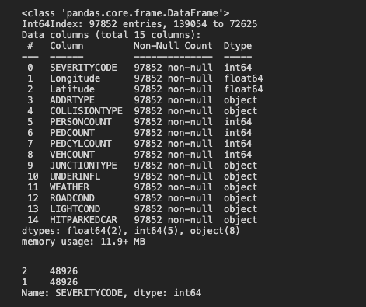

1. Creating the dummies variables from the categorial attributes

The cleaned dataset from upper procedure have several categorial columns inside, which could not be used directly in the machine learning process. In this step, I apply the *get.dummies()* function in the *pandas* library to create the dummy variables for the further model building procedure. The dummy variables cover different circumstance under each factor, which could offer a numerical description for the remained factors (including the junction type, collision type, weather and so on). The information for the final cleaned dataset is as follows (Figure 10).

*Figure 10 The cleaned dataset with dummy variables inside*

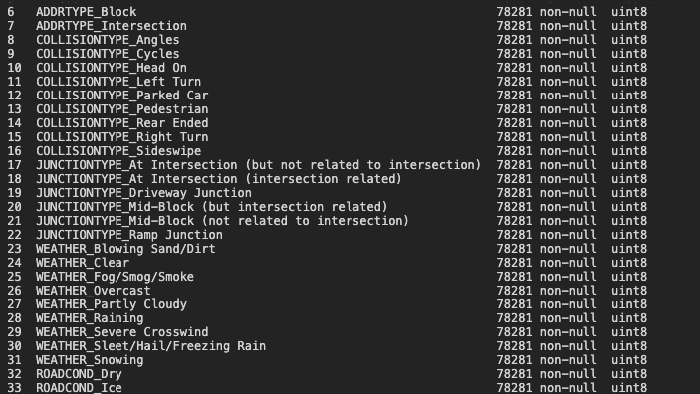

Then I separated the independent variables into dataset A as well as dependent variable (SEVERITYCODE) into dataset B. These two datasets are ready for the machine learning process.

1. Creating the training and testing subsets for the algorithms and data normalization

With the A and B datasets waiting to be analyzed, I use 8:2 scale to split two datasets separately into training and testing datasets. Both of the training datasets and testing datasets will be applied into the models in the following sections. The data normalization process is to make the performance of the following algorithms better.

1. Applying machine learning algorithms

The following sub-section presents the results of training and testing 4 algorithm models. With the result compared, we could have a clear view on the accuracies. The explanation about each algorithm will also be offered.

1. K Nearest Neighbors Classifier

This algorithm a non-parametric method proposed by Thomas Cover used for classification and regression. It uses the variables to classify the new cases through the majority of its “neighbors”. It could rely on labeled input data to learn a function that produces an appropriate output when given new unlabeled data. In this case, the output is as follows.

*Table 1 The KNN output*

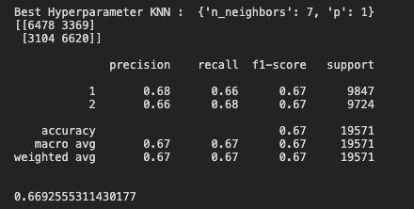

1. Logistic Regression

The logistic regression model is used to model the probability of a certain class. In this case, we can extend the logistic regression to model the impacts of independent variables (the different factors such as weather, road condition) on the dependent variable (collision severity). It works as a classifier that could estimate discrete values. Moreover, through fitting the existing data into the logistic regression function, this model could predict the probability of occurrence of collision severity. The output of the Logistic Regression Model is offered below.

*Table 2 The LC output*

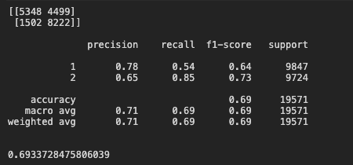

1. Naive Bayes classifiers

This model belongs to a family of simple "probabilistic classifiers" based on applying Bayes' theorem with strong (naïve) independence assumptions between the features. Naïve Bayes classifiers are highly scalable, requiring a number of parameters linear in the number of variables (features/predictors) in a learning problem.

*Table 3 The NC output*

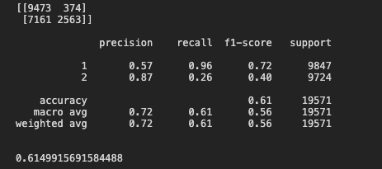

1. Support-Vector Machines Classifier

SVMs, also support-vector networks are supervised learning models with associated learning algorithms that analyze data used for classification and regression analysis. Given a set of training examples, each marked as belonging to one or the other of two categories, an SVM training algorithm builds a model that assigns new examples to one category or the other, making it a non-probabilistic binary linear classifier (although methods such as Platt scaling exist to use SVM in a probabilistic classification setting). The output is as follows.

*Table 4 The SVM output*

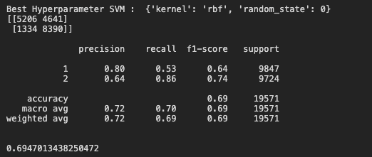

1. The comparison for accuracy of each algorithms

*Table 7 The comparison of the accuracy*

|  |  |  |  |  |
| --- | --- | --- | --- | --- |
| Algorithms | KNN | LC | NC | SVM |
| Accuracy (%) | 66.93 | 69.34 | 61.50 | 69.47 |

From Table 7, we could find that the highest accuracy among the models is still below 70%. The accuracy values fluctuated from 60% to 70%. That means the models could offer the prediction of the collision severity with 60%~70% accuracy. It also shows that SVM (Support-Vector Machines Classifier) is the best model that could offer a better prediction for the collision severity

**Conclusion**

In this report, I run 4 separate machine learning algorithms on the Seattle Collision dataset to predict the collision severity. With the output and accuracy, I also compared all these models. It is quite obvious that SVM model has the best accuracy and could present the better prediction. Meanwhile, based on the research procedure, I also find that the collision type, address type and external condition (weather, road and light) affect the collision severity. They have various correlation with the collision severity.

**Further Suggestions**

Through the research in this report, I could also find several issues with the dataset offered by Seattle traffic department. Here I provide some suggestions for the further research.

1. The traffic department should find some solutions to reduce the missing values of the collision datasets. This could increase the accuracy of machine learning algorithms;
2. The dataset description document could offer more explanations about the data attributes;